WEEK 2 REPORT
SUPERSTORE SALES ANALYSIS USING POWER BI
1.Project Title
Superstore Sales Analysis using Power BI

2.DAX Measures Created
The following measures were created for analysing the Superstore data:
- Total Sales – calculates the total sales value.
- Total Profit – calculates the total profit.
- Total Orders – calculates the number of unique orders.
- Total Quantity – calculates the total quantity of products sold.
- Average Sales – calculates the average sales value.
- Profit Margin % – calculates profit as a percentage of sales.

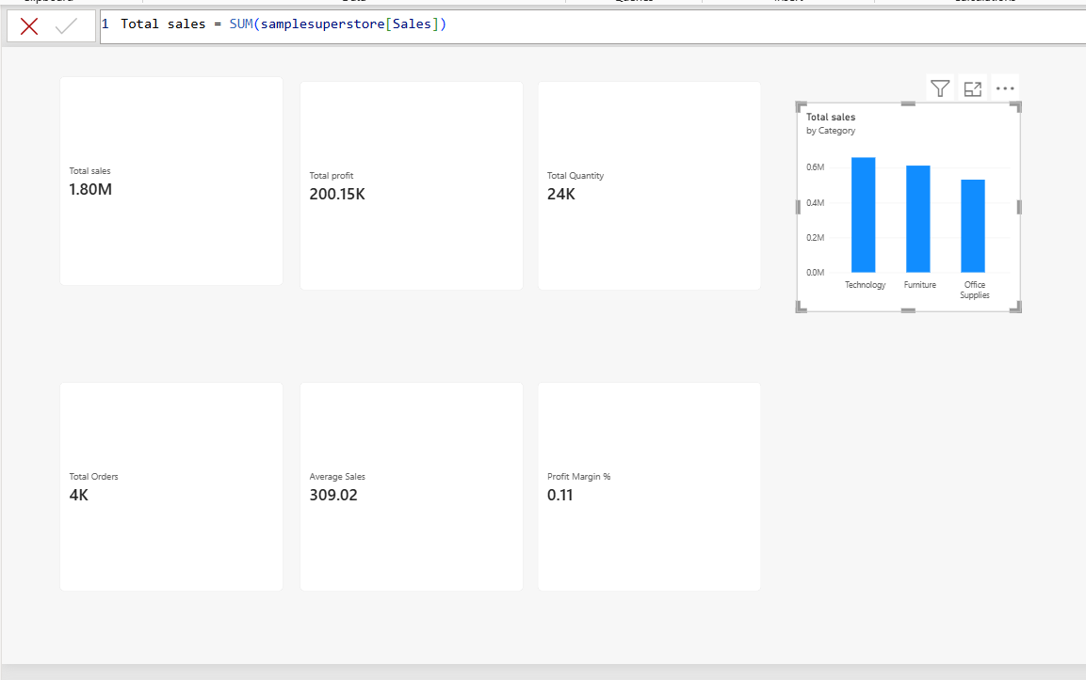
3.KPI Cards
Six KPI cards were created in the dashboard:
- Total Sales
- Total Profit
- Total Orders
- Total Quantity
- Average Sales
- Profit Margin %

4.Sales and Profit Visualizations
The following visualizations were created:
- Sales by Category – used to compare sales among different product categories.
- Profit by Region – used to compare profitability across different regions.
- Sales Trend – created using the Order Date hierarchy to analyse sales over time.
The Sales Trend uses the drill-down levels:
Year → Quarter → Month → Day
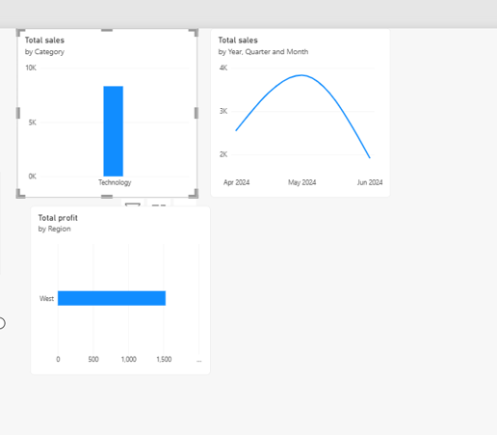
5.Interactive Slicers
Slicers were added to make the dashboard interactive.
The slicers include:
- Region
- Category
- Segment
- Order Year
These slicers allow users to filter the dashboard and analyse specific parts of the Superstore data.

6.Product Dimension
A separate DimProduct table was created.
It contains:
- Product ID
- Product Name
- Category
- Sub-Category
The Product Dimension helps organize product-related information in the data model.
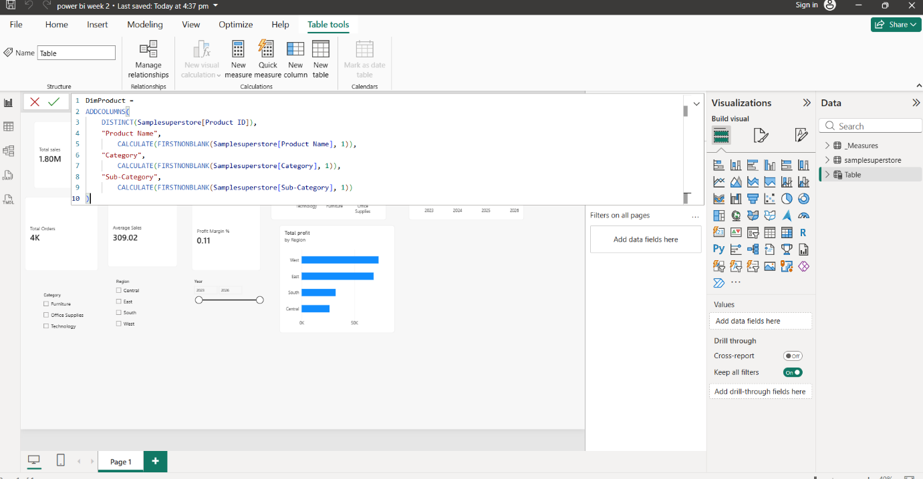

7.Date Dimension
A separate DimDate table was created for time-based analysis.
It contains:
- Date
- Year
- Month
- Month Number
- Quarter
- Day
- Day of Week
The Date Dimension helps analyse and filter sales based on different time periods.
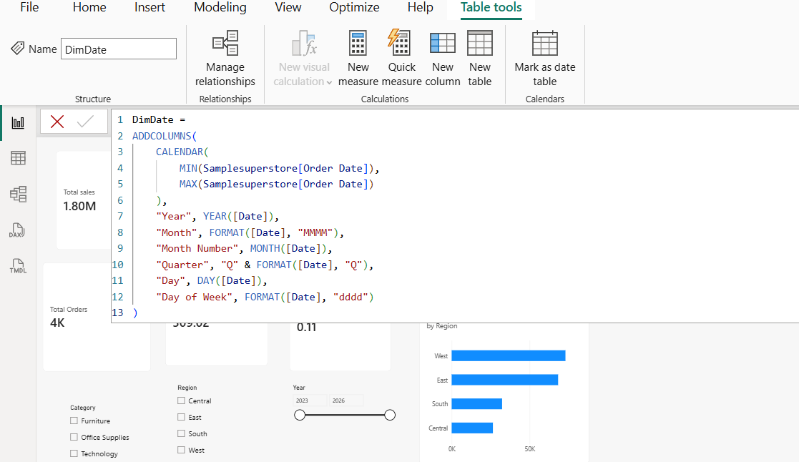

8.Data Model
The Power BI data model was organized using:
- Samplesuperstore – main transaction table
- DimProduct – product information
- DimDate – date information
- _Measures – DAX measures
Relationships were created between the supporting dimension tables and the main Superstore table. This creates a structured model for dashboard analysis.
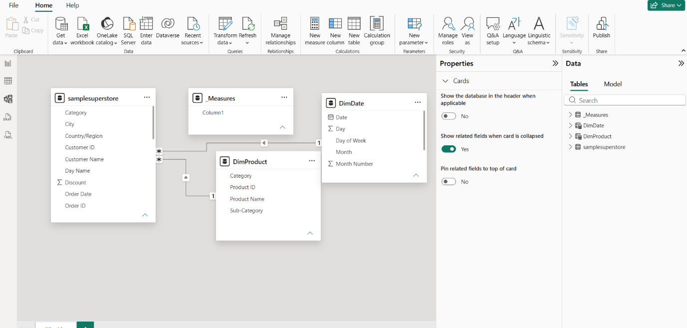

9.Conclusion
During Week 2, the cleaned Superstore dataset was transformed into an interactive Power BI dashboard. DAX measures, KPI cards, charts, slicers, a Product Dimension, and a Date Dimension were created. The data model was also organized to make the dashboard easier to analyse and manage.

